GDAA 3000: Tsetspa7 notes

Author: Ryan Milia

February 21, 2025

### Introduction:

The purpose of these notes is to document the workflow and progress of my final project for the GDAA 3000 course at COGS. I will note the process of each step required for the successful completion of the project.

### Data Cleaning/Processing:

My raw LiDAR data came in two different folders. The first folder contained LAZ files. I had to convert these into LAS format using the “Convert LAS” tool in ArcGIS Pro. I had to research how to do this as a batch conversion, where I learned that right-clicking on the tool revealed a batch operation. Converting all 298 LAZ files took over 4 hours. I created a folder named “Unzipped_LAS” which contained all unzipped and converted LAS files. The second folder contained several individually zipped LAS files. To unzip the contents of my second folder, I used 7zip. While unzipping my files and converting from LAZ to LAS, I started to run out of storage on my PC. I decided to move all unzipped files to my external drive to save space while the rest of my LAZ files were being converted.

I wrote the following code in cmd prompt to extract all zip files to a new folder:

for %f in (*.zip) do "C:\Program Files\7-Zip\7z.exe" x "%f" -oC:\Users\ryanj\Desktop\project\data\T7_lidar\unzip

Challenges during data processing include poor internet connection and large datasets requiring ample storage and external disk drive management. Converting from LAZ to LAS was time consuming, and it took active management to manage the large amount of LiDAR data.

### Creating Data Derivatives:

Adding the LiDAR data from external drive to ArcGIS Pro worked well, but the LiDAR does not fill the full project area. Figure 1 shows the LiDAR within the project area. I thought this would be an issue, but when I asked the client representative about the missing LiDAR, he told me that this was the area of interest within the project area, and that I can shrink the project size to match the LiDAR extent.

*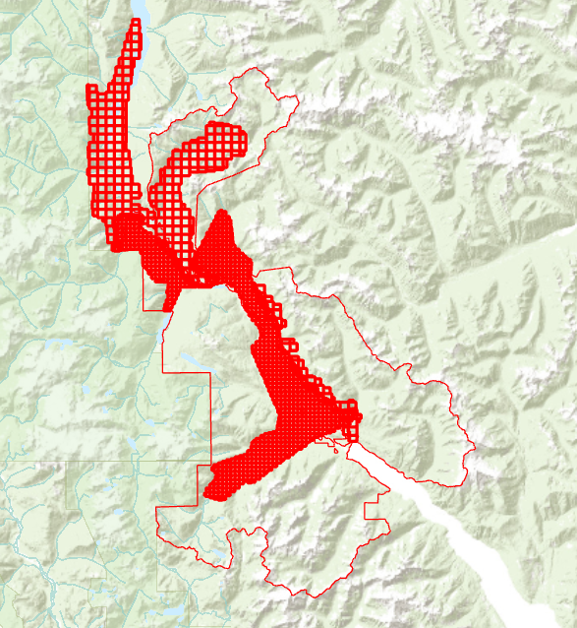  
Figure 1. LiDAR within project area.*

With the LiDAR dataset, I derived 2 DEM models. I used the “LAS Dataset to Raster” tool in ArcGIS Pro. Figures 2 and 3 show the parameters for DEM creation. Each DEM took several hours to create.

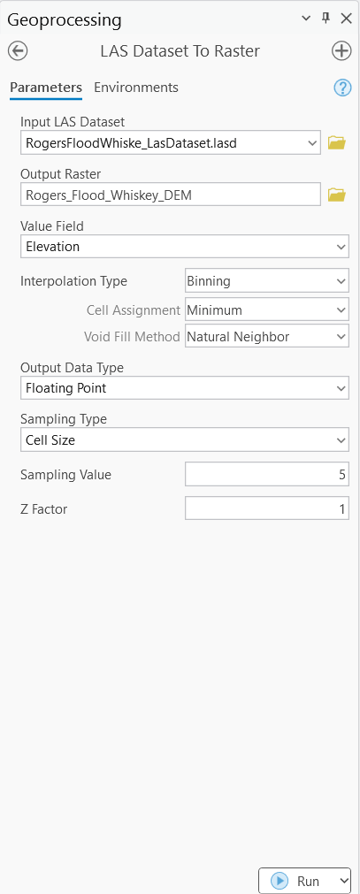 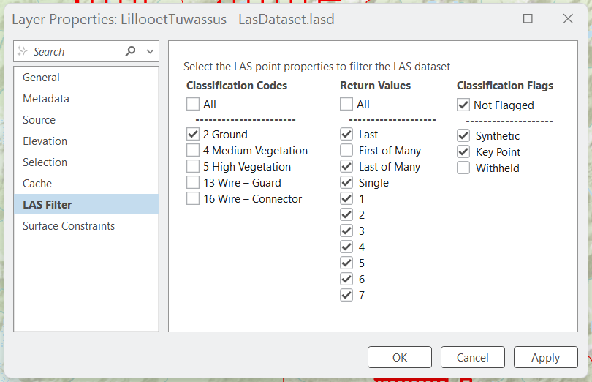   
*Figure 2. Rogers Flood Whiskey DEM creation parameters.*

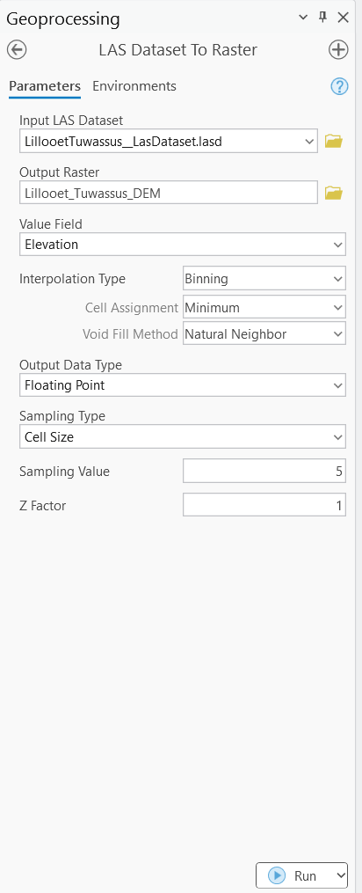 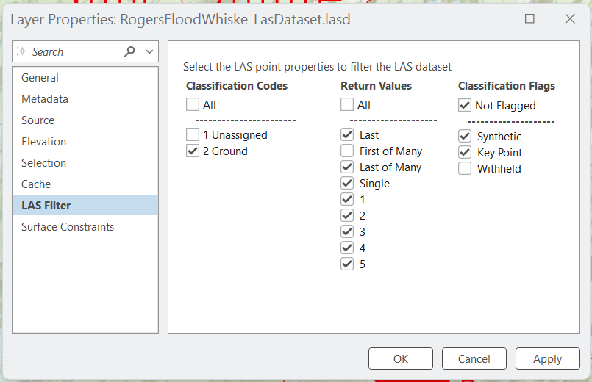  
*Figure 3. Lillooet Tuwassus DEM creation parameters.*

I had troubles with the DEM creation. I was careful with parameter settings but there was always something that I missed, such as setting extents. Figure 4 shows the result of not setting extents and with “Void Fill” set to “Natural Neighbor”. I also ran both LAS Data to Raster processes without using a void fill method.

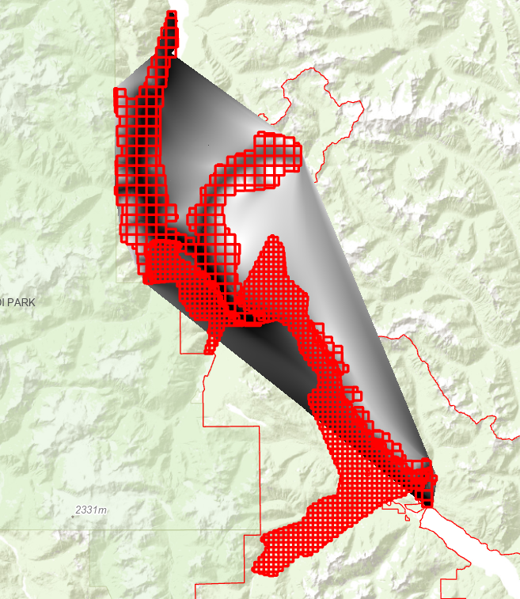  
Figure 4. DEM without setting extents.

For DSM creation, I set the parameters similarly to the DEM using the “LAS Dataset to Raster” tool. Figures 5 and 6 show the parameter settings.

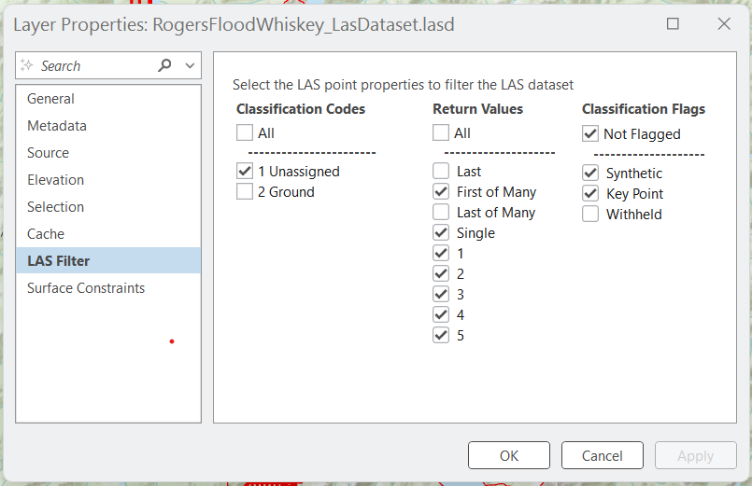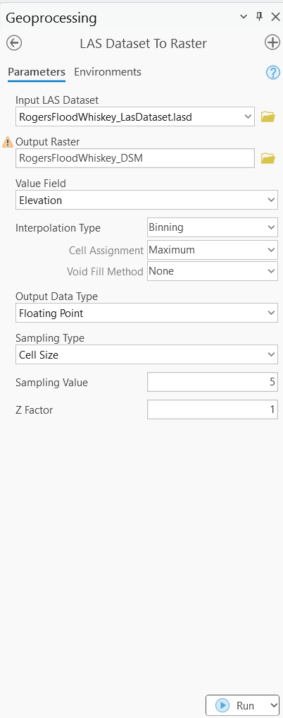  
Figure 5. Rogers Flood Whiskey DSM creation parameters.

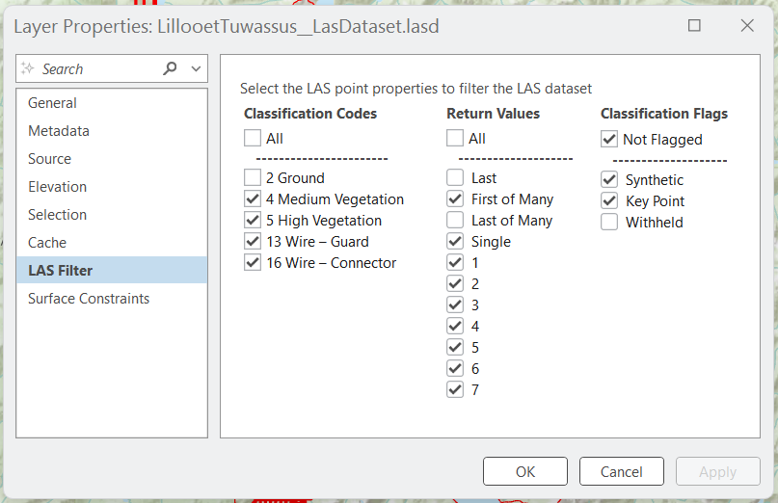  
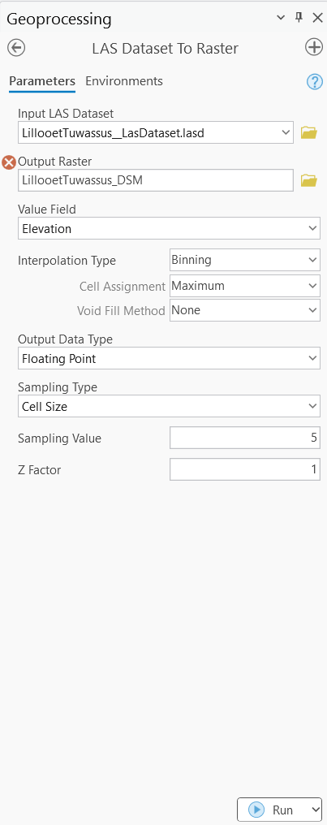  
Figure 6. Lillooet Tuwassus DSM creation parameters.

Some of the LiDAR was outside of my project area, so I had to clip the derived rasters to the project boundary. The project boundary was in KML format, so I had to convert it into a feature layer. I then exported the feature layer as a SHP file so that I could clip the derived rasters. I used a batch operation with the “Clip Raster” tool to clip all derived rasters in one operation. Figure 7 shows the parameters for my batch “Clip Raster” operation.

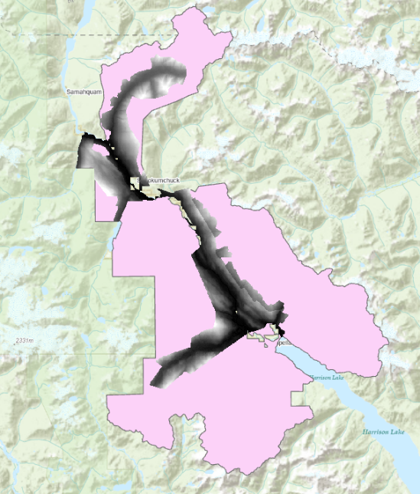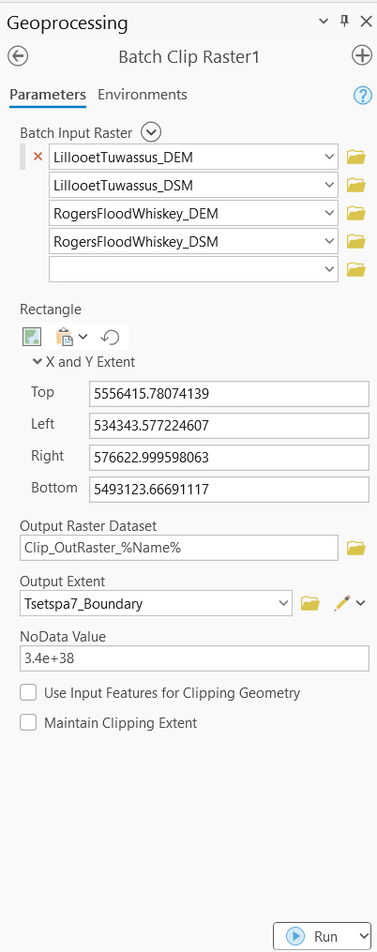  
Figure 7. Batch Clip Raster operation. Figure 8. Result of Clip Raster Operation.

Next, I created two CHM models using the “Calculate Raster” tool. Figures 9 and 10 show the parameters for CHM Creation.

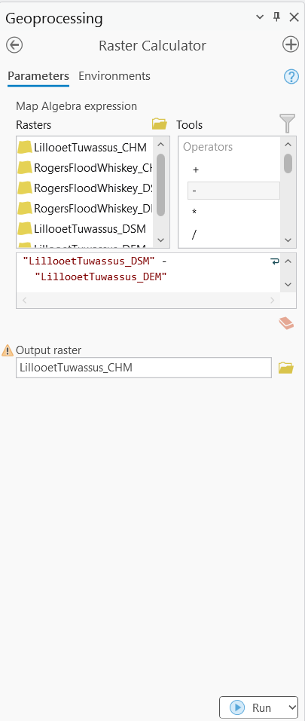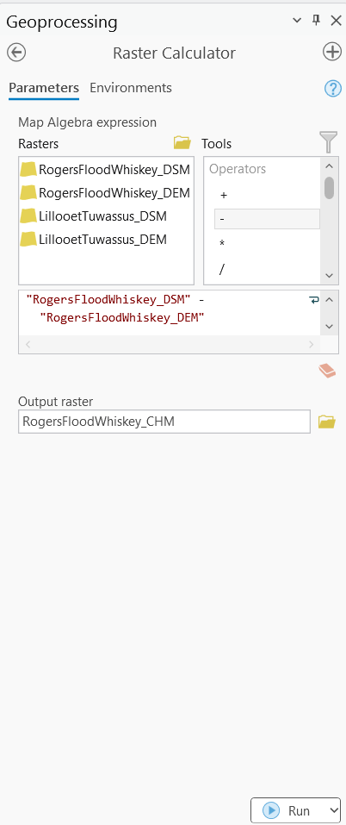  
Figure 9. Rogers Flood Whiskey CHM creation parameters. Figure 10. Lillooet Tuwassus CHM creation parameters.

Now that I had my 2 canopy height models and 2 digital elevation models, my next step was to merge my rasters so that I have 1 DEM and 1 CHM. I used the “Mosaic to New Raster” tool to combine my rasters.

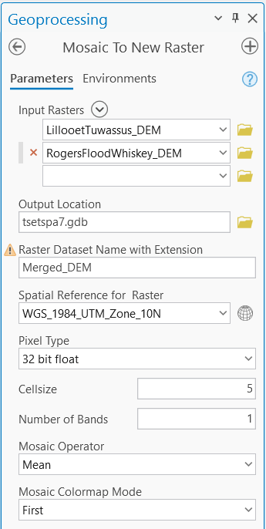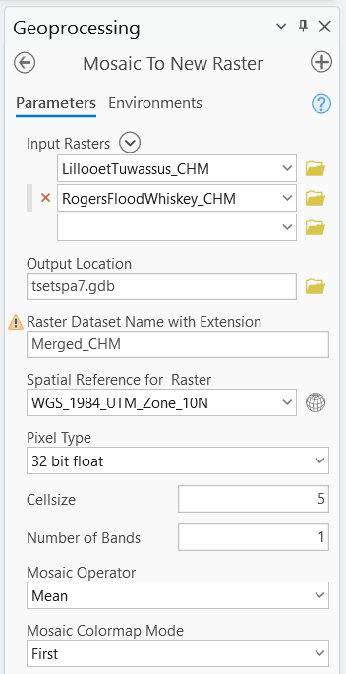  
Figure 11. Mosaic to New Raster: CHM. Figure 12. Mosaic to New Raster: DEM.

For my newly merged DEM and CHM, I noticed that there was a display issue. Bands of data were missing when zooming out. I believe this to be a pyramids and display issue. Figure 13 shows the CHM pyramid issue.

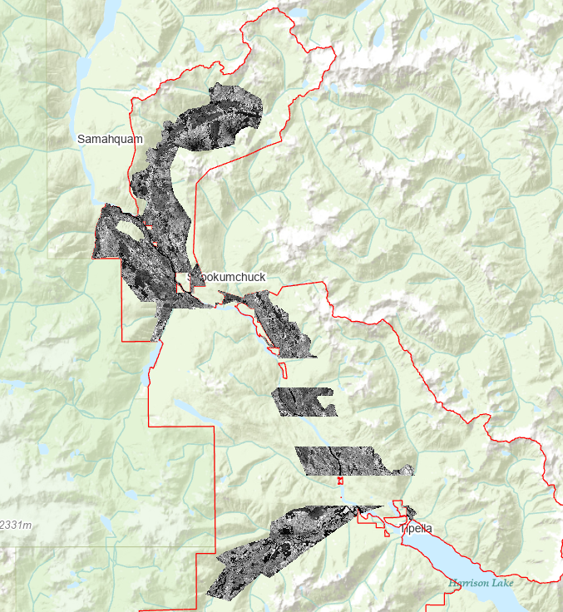  
Figure 13. CHM Pyramid Issue.

Solution to Pyramid Issue:

I inspected my raster files and found that the DEM and CHM were in WGS 1984 (GCS) when the rest of the project was in NAD 1983 UTM Zone 10N (PCS). I reprojected both raster files and this solved the issue.

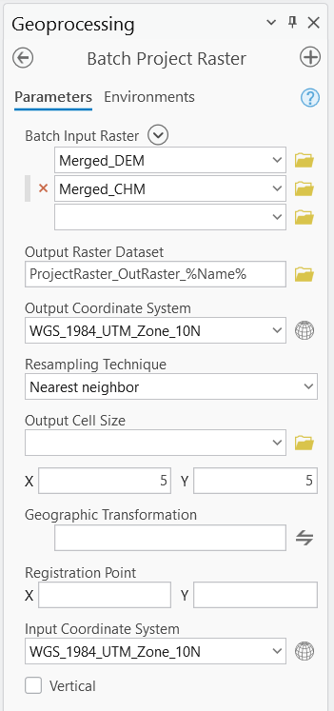

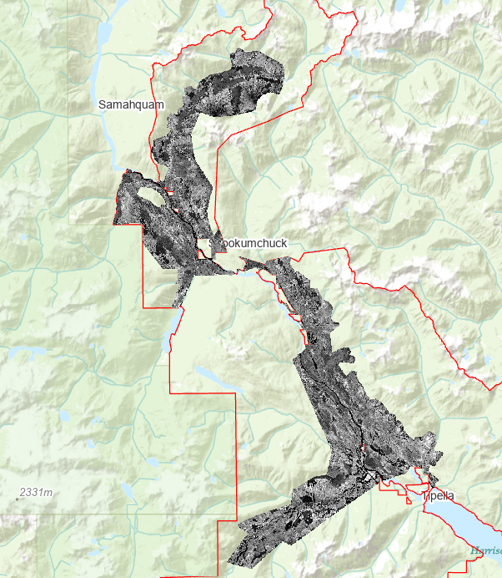  
Figure 14. Reprojected CHM. Figure 15. Batch Project Raster Parameters.

### VRI Classification:

I opened all 3 VRI datasets in ArcGIS Pro. Each dataset had many columns and rows. My first step was to clip the datasets to my project area. I did a batch “Clip” operation, clipping all 3 datasets to the Tsetspa7 boundary. Next, I decided to verify the contents of the VRI. I found that the VEG_COMP_LYR_L1_POLY had all the columns needed for my analysis. VEG_COMP_LYR_R1_POLY and VEG_COMP_POLY_2023 did not have any information that was not already provided by the other dataset, these two layers were removed from my project. I opened my attribute table and field view so that I could toggle layer visibility. I turned off all fields that were unnecessary to my analysis.

I created several fields for VRI classification. For each field calculated, I will include the python expression used for the “Calculate Field” function.

**Forest Type:** Classified based on species ID.

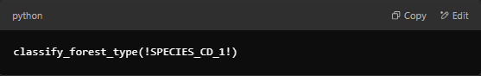

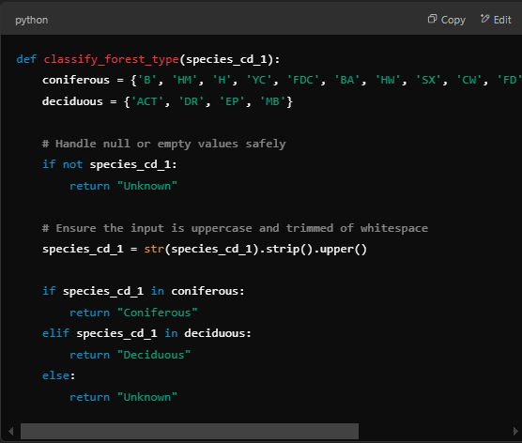

**Crown Closure:** Classified based on crown closure: 0-30% (Low), 30-70% (Medium), 70-100% (High).

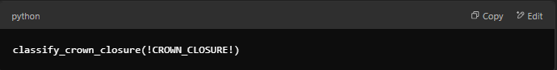

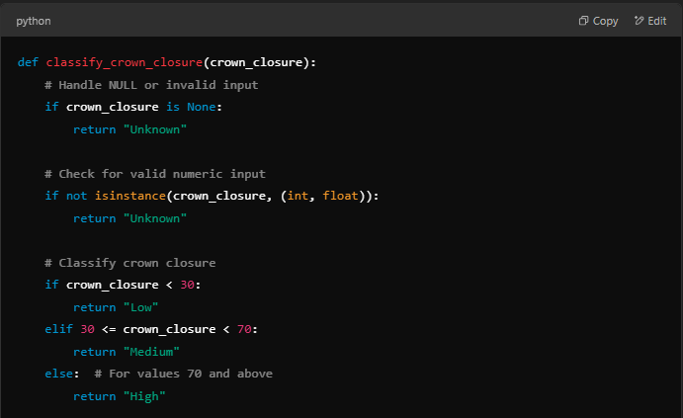

**Stand Age:** Classified based on BC Forest Management and Conservation definitions: 0-40 (Young), 40-100 (Mature), 100+ (Old Growth.

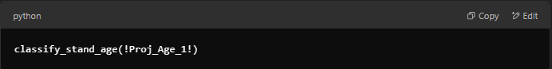

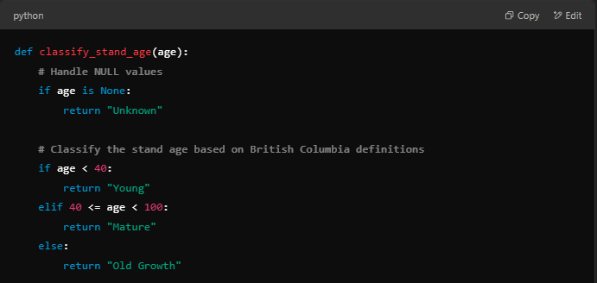

**Vertical Complexity:** Classified by vertical complexity: Low (0-2), Medium (2-4), High (4+).

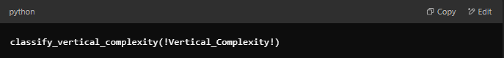

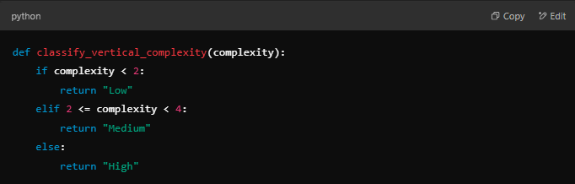

**BEC Zone:** Classified by BEC Zone: CWH or MH (High Suitability), Else (Low Suitability).

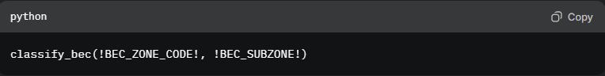

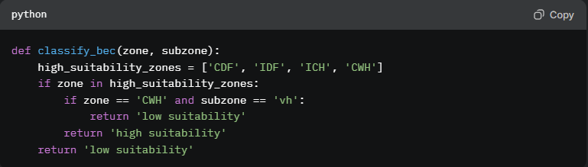

ABOVE IS WORK PRIOR TO FEB.28.2025. BELOW IS WORK FOLLOWING PROGRESS REPORT #1.

Now that I had my classified VRI data, I decided to clip all VRI layers to my project boundary, specifically to the LiDAR extents. To do this, I had to convert my CHM to a vector polygon so that I could clip my VRI. To do this, I had to classify the CHM, so it included the “Value” field.

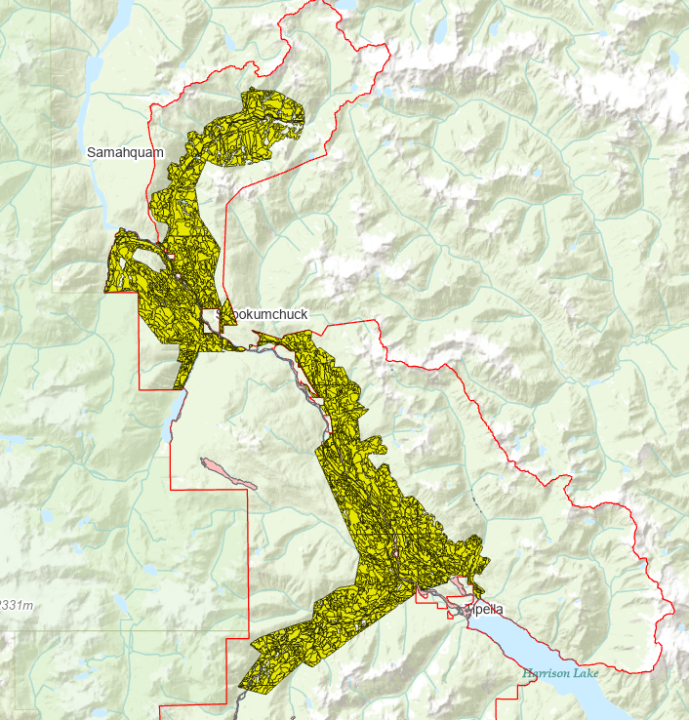  
Figure 16. Clipped VRI layer.

My next step was to create a water body mask for all layers. I used the Statistics Canada dataset named “Water File - Lakes and Rivers” to mask my layers. I downloaded the water layer and projected it to NAD 1983 UTM Zone 10N (PCS). I then had to use the “Polygon to Raster” tool to create the raster mask (See Figure 17). Next, I used the “Raster Calculator” tool to give lakes and rivers a value of 1, and water free areas no value. My next step was to use the “Extract by Mask” tool to exclude water bodies from my CHM and DEM (Figure 18).

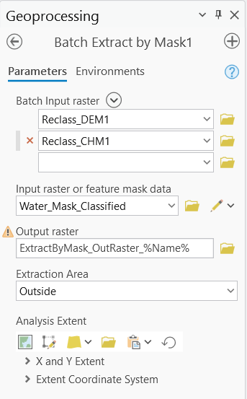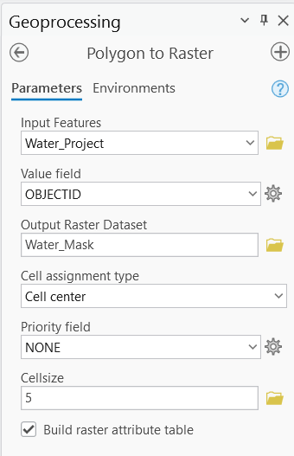   
Figure 17. Polygon to Raster Parameters. Figure 18. Extract by Mask Parameters.

My next step was to make sure my VRI data did not contain water features. I used the “Erase” tool to remove all water features from the VRI data. I noticed that there was some missing VRI data (see Figure 20).

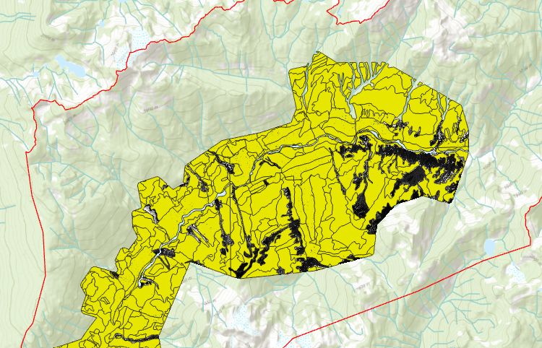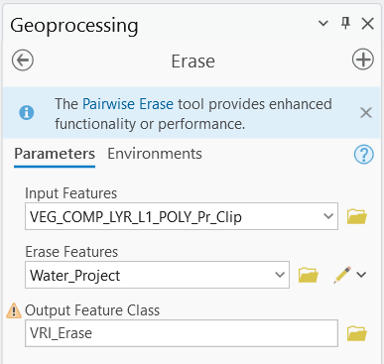   
Figure 19. VRI Erase Parameters. Figure 20. Missing VRI Data.

I verified with the original VRI dataset that the missing polygons never existed, and that I did not lose data during processing. My options were to artificially fill in missing VRI areas, or to clip my DEM and CHM to the VRI extent. I did not feel that artificially filling in VRI areas would be accurate, so I decided to clip my DEM and CHM to the VRI extent. For this, I used the batch “Extract by Mask” tool.

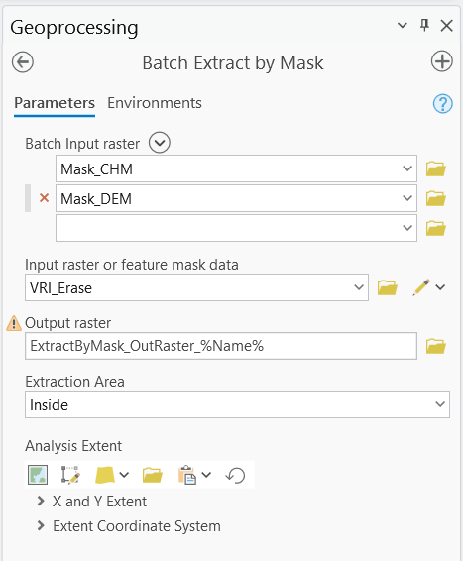  
Figure 21. Batch Extract by Mask Parameters.

My next step was to rasterize my VRI data so that I can use it in my MaxEnt model. I already classified my VRI data, so I had to rasterize each classification: Forest_Type, Crown_Closure_Class, Stand_Age_Class, Vertical_Complexity, and BEC_Suitability_Class. I set the cell size to 5m for each classification to match my DEM and CHM. The parameters and corresponding raster visualization for each “Polygon to Raster” operation is found in Figures 22 – 26.

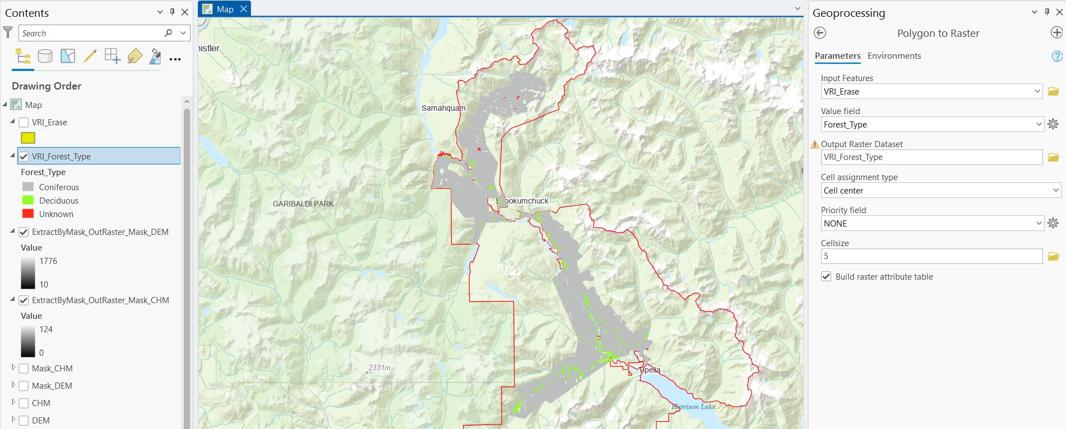  
Figure 22. Forest Type Raster.

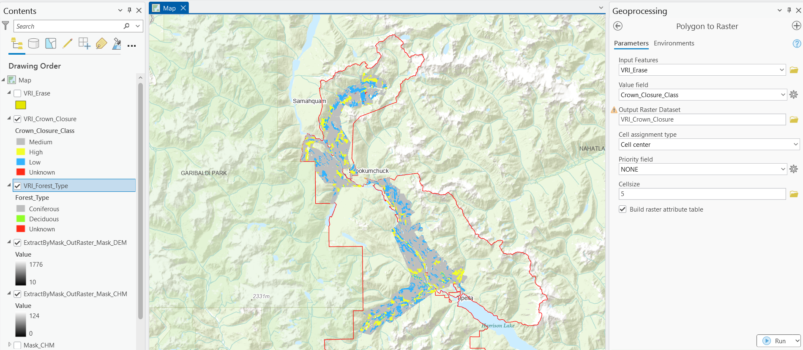  
Figure 23. Crown Closure Raster.

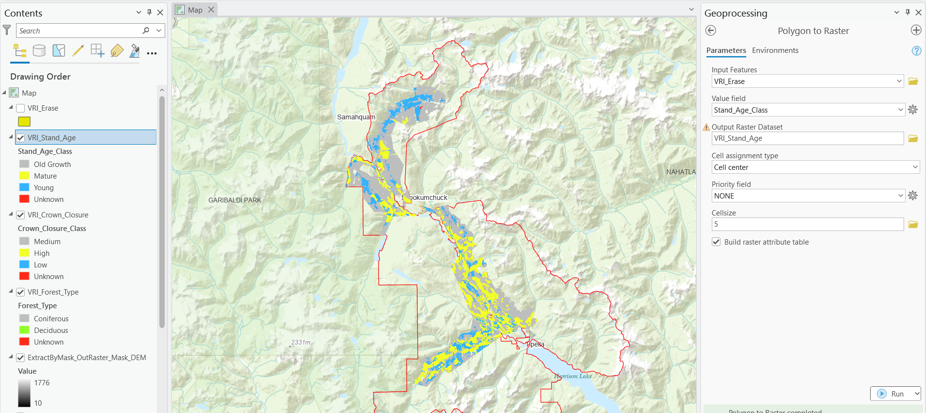  
Figure 24. Stand Age Raster.

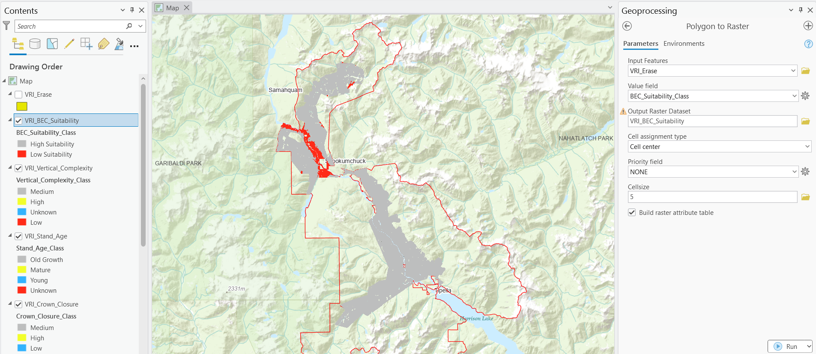  
Figure 25. BEC Suitability Raster.

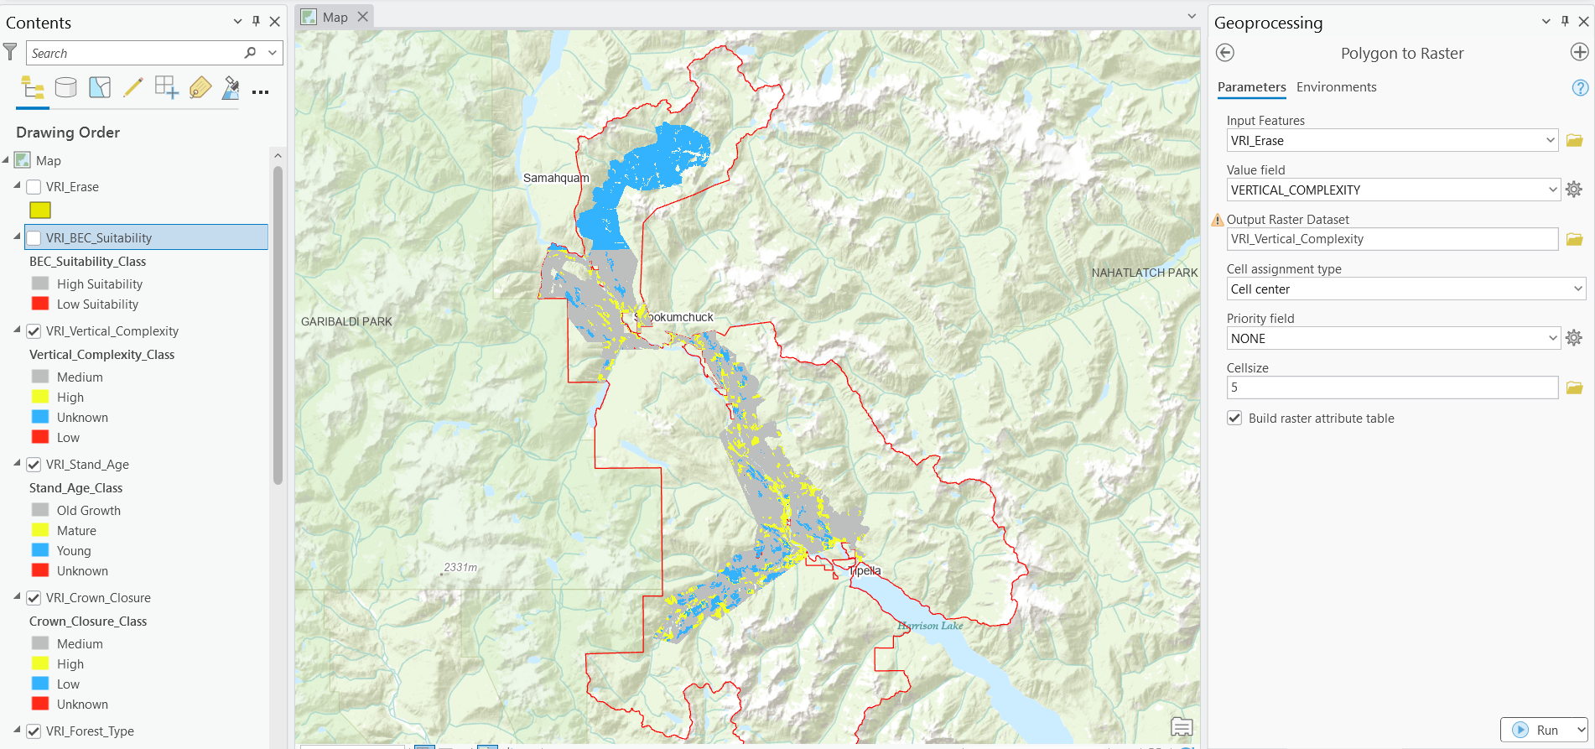  
Figure 26. Vertical Complexity Raster.

I decided to address unknown values. I found that there were unknown values for the same 3 polygons in my VRI data in the northern section of the boundary. These polygons are found in Figure 27.

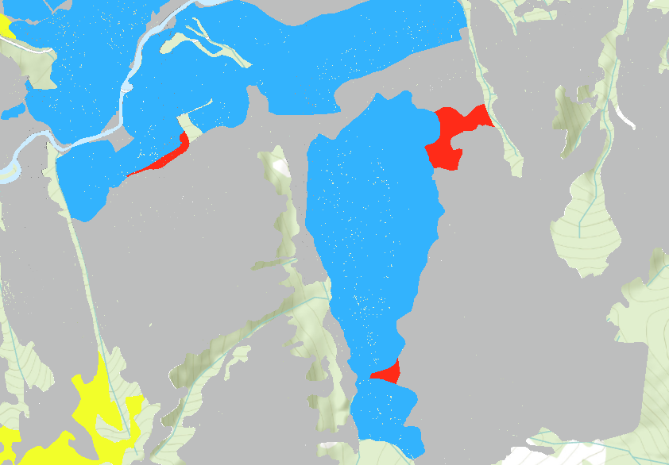  
Figure 27. Problematic Polygons.

The northern section of the boundary also had unknown vertical complexity throughout. This is shown in Figure 28.

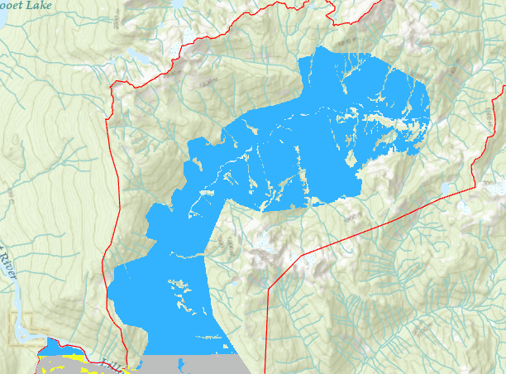  
Figure 28. Unknown Vertical Complexity.

I had to determine whether the unknown values for vertical complexity would contribute to meaningful results in my MaxEnt model. I checked the original VRI data, and vertical complexity was NULL for the whole northern section of the project area.

Given that the vertical complexity classification is missing data for much of the project area, it could significantly impact the reliability of the results in the MaxEnt model. The large proportion of unknown data may introduce noise or bias, making it challenging to draw meaningful conclusions. To maintain the quality of the model and focus on variables with more consistent and reliable information, I decided to drop the vertical complexity raster from the analysis.

Now that I dropped vertical complexity from the analysis. There were very few unknown values from my VRI data. Some of the polygons had data from one classification but missing data from another. I was considering imputing the values from nearest neighbor but decided that this might bring inaccuracies to my analysis.

For a forest-based analysis, imputing missing values using methods like the nearest neighbor could introduce inaccuracies, as forest data often exhibit complex spatial variability that may not be captured well by simple imputation techniques. In this case, imputation might not be appropriate because forest characteristics can vary significantly across relatively small distances, and filling missing data could result in misleading predictions or assumptions that do not reflect the actual conditions.

Final Checks:

Now that I had my classified VRI data and my DEM/CHM, I had to verify that everything was in the same coordinate system and had the same resolution. I verified that each raster had a cell size of 5m and was projected to NAD 1983 UTM Zone 10N (PCS). There were also very few “Unknown” fields for my VRI based rasters. I decided to include the unknown values in my model rather than impute them artificially. Now that my rasters were verified, I exported them.

My next check was to verify that all layers had the same spatial extent. Figure 31 shows the extent of my first layer (T7_Stand_Age).

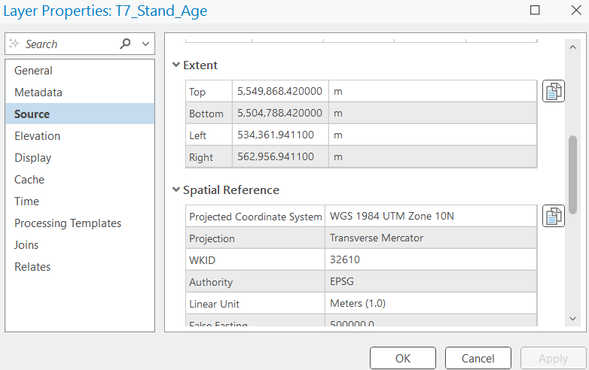  
Figure 29. T7 Stand Age Spatial Extent.

All raster files had the same spatial extent, except for my DEM and CHM which were very close but not exact. I used the batch “Resample” tool to set the extent of my VRI derived raster layers to match my DEM and CHM (see Figure 30 and Figure 31).

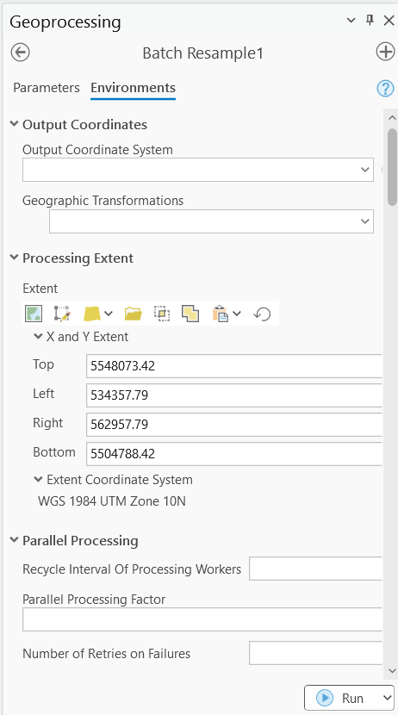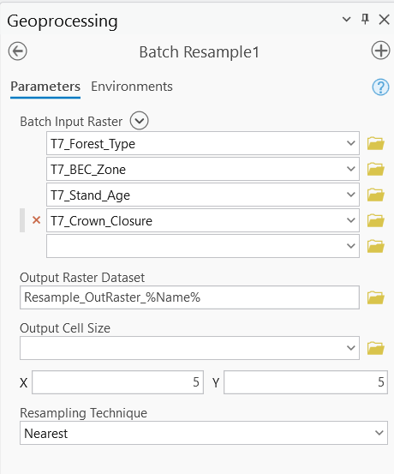  
Figure 30. Batch Resample Parameters. Figure 31. Batch Resample

Parameters.

This did not work. My extent differences are found below: (The bottom values are the same).

**Top**: DEM = 5,548,073.42, VRI = 5,549,868.42 → Difference = 1,795 meters.

**Left**: DEM = 534,357.79, VRI = 534,361.94 → Difference = 4.15 meters.

**Right**: DEM = 562,957.79, VRI = 562,956.94 → Difference = 0.85 meters.  
  
Solution:

I found that when I masked the water features from my DEM and CHM, for some reason it changed my extent. I ran the “Extract by Mask” tool again for the DEM and CHM but set the extent to “VRI_Forest_Type”. This made the extent the same for the top and bottom, but the left and right were still different. My final solution was to use the “Resample” tool, but to use the “Snap Raster” function and set it to the same extent as the “T7_Crown_Closure” layer for both the DEM and CHM, this solved the issue.

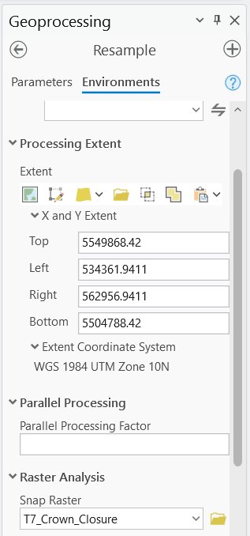  
Figure 32. Resample Parameters.

Below is a checklist of all the verifications that I performed:

**1. Coordinate System:** all data is projected to NAD 1983 UTM Zone 10N (PCS).

**2. Resolution:** all rasters share a resolution of 5m.

**3. Extent:** all files now share the same extent.

**4. Missing Values:** very few missing values, I decided not to impute missing values and to drop Vertical Complexity from the analysis due to missing values for the whole northern section of my project area.

**5. File Naming & Format:** all files are in raster format.

After verifying my VRI data and LiDAR-derived models, I was nearly ready to begin my MaxEnt modeling. To integrate my species occurrence data, I converted the KML file to a vector point layer using the "KML to Layer" tool, then clipped it to my project area with the "Clip" tool and reprojected it to WGS 1984 UTM Zone 10N using the "Project" tool. While the points displayed correctly, the layer lacked an explicit geometry field, so I added "x" and "y" fields to the attribute table and used the "Calculate Geometry" tool to populate them with coordinates. I then exported the dataset as a CSV file for use in MaxEnt. Upon review, I found 24 occurrence points, but 12 were duplicates, so I removed them to avoid redundancy and ensure a more accurate species distribution model.

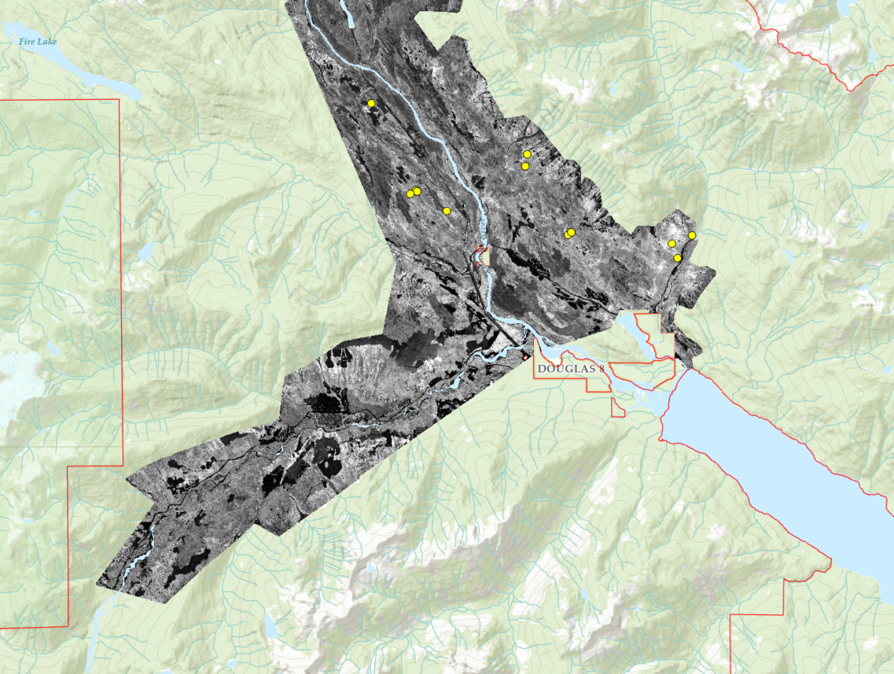  
Figure 33. Goshawk Locations.

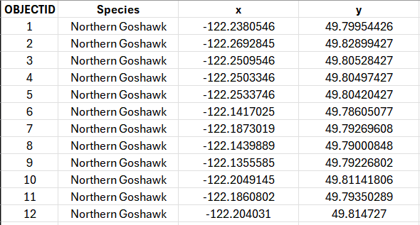  
Figure 34. Goshawk Locations CSV.

I have now verified my input data, ensuring it meets the necessary criteria for the MaxEnt modeling process. This includes confirming the coordinate system, resolution, extent, and addressing any missing values. With the data now complete and fully checked, I have successfully completed my checklist and am ready to proceed with the modeling process. I exported all raster files as tif files and put them in my RStudio data folder named “tsetspa7”. I also included my CSV file containing species occurrence data.

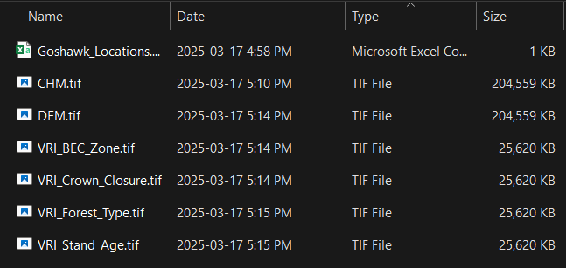  
Figure 35. MaxEnt Model Input Data.

I found out that I need to classify my raster layers numerically. Below, I will list the changes made during reclassification.

BEC_Suitability:

Low Suitability: 0  
High Suitability: 1

Crown_Closure:

High: 1  
Medium/Unknown: 2  
Low: 3

Stand_Age:

Old Growth: 1  
Mature/Unknown: 2  
Young: 3

Forest_Type:

Coniferous: 1  
Deciduous: 0  
Unknown: 2

I also found out that my species occurrence data needed to include my environmental variables. It also had duplicate points. I had to find the identical points using the “Delete Identical” tool. The goshawk locations now had no duplicate points. To include the environmental variables in my species occurrence data, I used the “Extract Multi Values to Points” tool. This included the scoring from each variable into my species occurrence data.

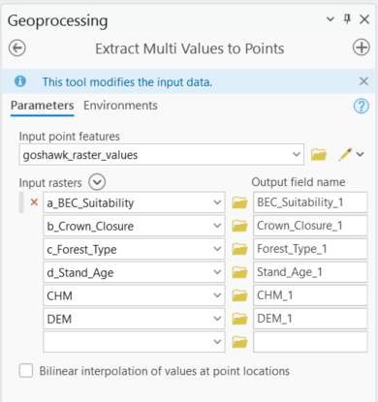  
Figure 36. Extract Multi Values to Points Parameters.

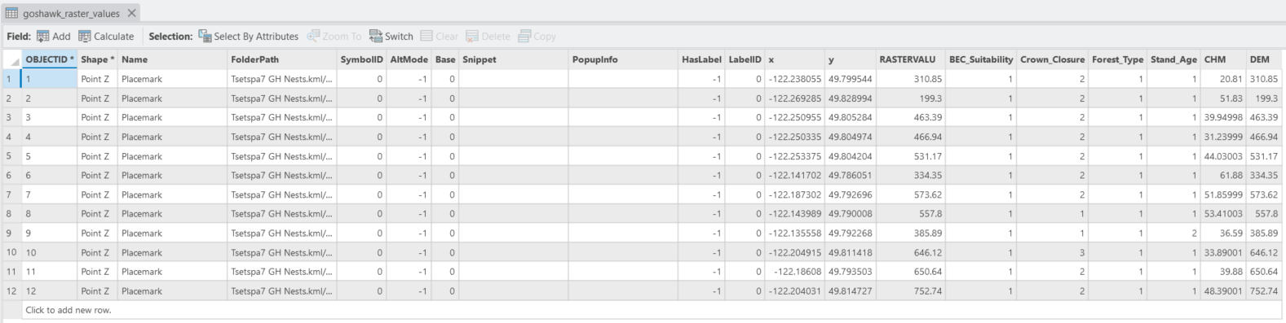Figure 37. Final Species Occurrence Data Attribute Table.

MaxEnt Modeling:

For my MaxEnt model, I used RStudio and documented the entire modeling process in a markdown notebook titled "tsetspa7_model". This notebook details each step of the analysis, serving as a comprehensive record of the workflow throughout the modeling process. I also created a second model that uses the original 12 occurrence points but also creates synthetic occurrence points based on the conditions of the original points. This model is named “tsetspa7_synthetic_model”. I then compared both models to see if the original model performed well compared to a synthetic model with more species occurrence points.

Comparing original MaxEnt model with synthetic MaxEnt model: (evaluated using the following metrics)

* **AUC (Area Under the Curve):** Measures how well the model separates known goshawk locations from random background points. Closer to 1 means better accuracy.
* **Predicted Suitability:** The model assigns a score to every location, showing how good it is for goshawks. Higher scores mean better habitat.
* **Presence and Background Points:** The number of real goshawk locations and random points used to train the model.

Model 1 uses 12 occurrence points and a regularization multiplier (regmult) of 6 to prevent overfitting, as higher regularization simplifies the model and enhances generalizability for small datasets. Model 2 incorporates 212 occurrence points (12 original plus 200 synthetic points) and sets regmult to 2, allowing a more complex model to capture detailed environmental relationships, as the larger dataset reduces overfitting risk.

**70/30 Split Test Results**

Both models used a 70/30 train-test split, but Model 2, with 212 occurrence points (including 200 synthetic), outperforms Model 1, which has only 12 points. Model 2's average prediction for test presence points is higher (0.5122 vs. 0.3985), indicating better sensitivity to true positives. Model 2 shows moderate predictions for background points (0.0870), which is higher than Model 1's near-zero background predictions (0.0005), suggesting somewhat less specificity but still good discrimination between presence and background.

**LOOCV Results**

Leave-One-Out Cross-Validation (LOOCV) shows Model 2's superior performance with an AUC of 0.9567 compared to Model 1's 0.9182, indicating better overall discriminatory ability. Model 2's mean predicted suitability (0.1763) is higher than Model 1's (0.0818), reflecting broader applicability across the study area. Model 2's maximum suitability (0.9398) is also higher than Model 1's (0.7730). Model 1 achieves higher mean suitability for the original 12 presence points (0.7090 vs. 0.5028), suggesting it is more tailored to the limited original data.

**K-Fold Cross-Validation Results**

Model 2 underwent 5-fold cross-validation, yielding an AUC of 0.9500 and a mean predicted suitability of 0.3448, with strong differentiation between presence (0.5052) and background (0.1867) points. This robust validation was feasible due to Model 2's 212 occurrence points, allowing stable training and testing splits. In contrast, Model 1's 12 occurrence points made k-fold cross-validation impractical, as splitting such a small dataset would lead to high variance and unreliable performance estimates.

**Area Distribution Results**

The 3-level area distributions show differences between models:

Model 2: Low (47.94%), Medium (33.61%), High (18.44%)

Model 1: Low (32.95%), Medium (28.47%), High (38.58%)

The 5-level distribution also shows differences:

Model 2: Very Low (40.96%), Low (6.99%), Medium (33.61%), High (7.53%), Very High (10.92%)

Model 1: Very Low (32.95%), Low (10.35%), Medium (28.47%), High (7.76%), Very High (20.46%)

Model 2 identifies more area as Low/Very Low and less as High/Very High compared to Model 1.

**Conclusion**

Model 2 remains the stronger choice for presentation due to its higher AUC (0.9567 in LOOCV, 0.9500 in k-fold), robust validation from a larger dataset, and better generalization. The updated results show Model 2 has excellent discrimination ability while being less extreme in its predictions than Model 1. While Model 1 shows higher suitability for the original 12 points (0.7090 vs. 0.5028), Model 2's larger dataset provides more reliable predictions across the study area. When presenting the results, emphasize Model 2's broader applicability while acknowledging Model 1's precision for the original data as a useful baseline comparison.

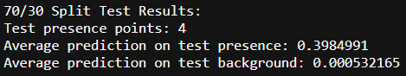  
Figure 38. Model 1 70/30 Test Results.

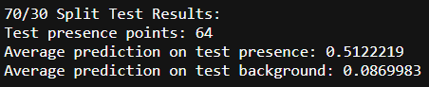  
Figure 39. Model 2 70/30 Test Results.

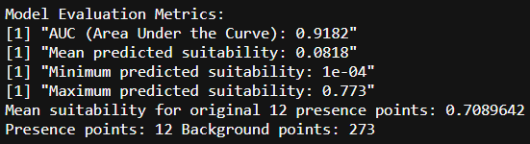  
Figure 40. Model 1 LOOCV Results.

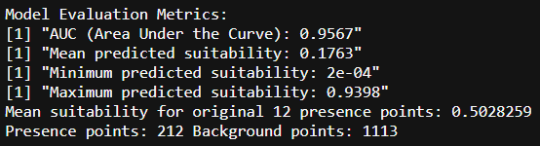  
Figure 41. Model 2 LOOCV Results.

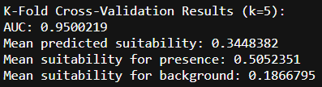  
Figure 42. Model 2 K-Fold CV Results.

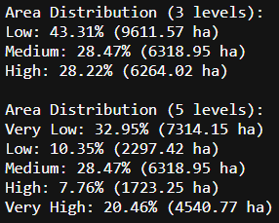  
Figure 43. Model 1 Area Distribution.

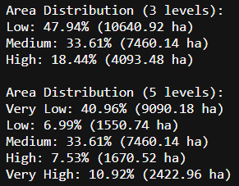  
Figure 44. Model 2 Area Distribution.

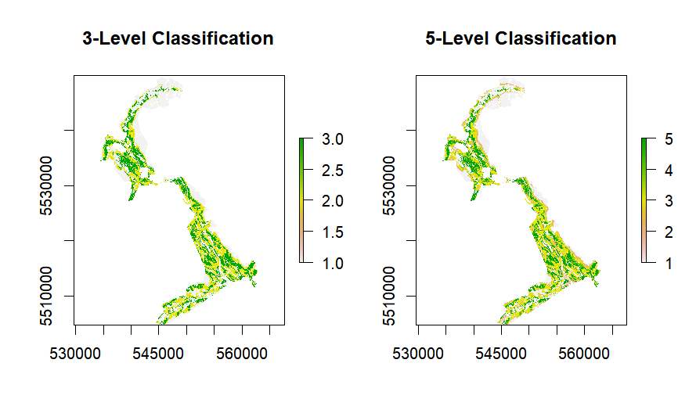Figure 45. Model 1 Classification.

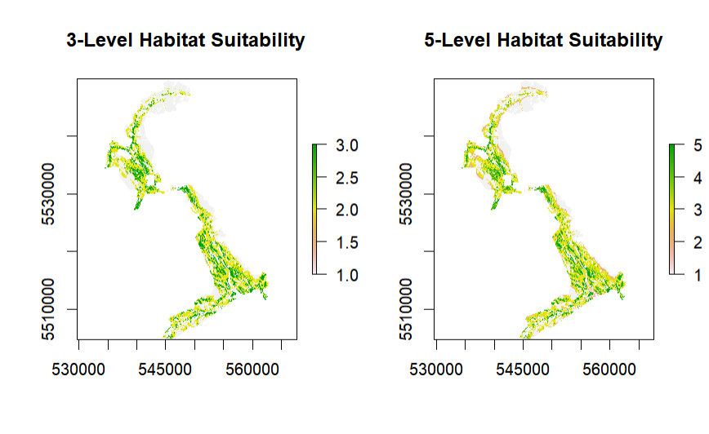Figure 46. Model 2 Classification.

Feature Selection:

I have decided to reconsider feature selection for my MaxEnt models. My correlation matrix revealed a high correlation between stand age and BEC zone, so I decided to use CHM instead of stand age for the model.

Final Decision:

I have decided to keep the original feature selection for my original model (stand age, forest type, BEC zone)

* Better discrimination (70/30 test: presence 0.398 vs. background 0.0005, larger gap than updated models 0.510 vs. 0.382).
* Higher suitability for known presence points (0.709 vs. 0.614), critical for 12 points.
* More conservative predictions, reducing overprediction risk. The updated model’s slightly higher AUC (0.9417 vs. 0.9182) is offset by weaker specificity and overpredicted background suitability.

Synthetic Model:

I decided to add DEM and CHM as predictors. This was feasible due to the addition of synthetic points. The updated feature selection is included in the final model. The comparisons above have been updated to compare both final models.

Comparing Habitat Maps:

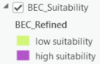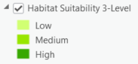Habitat suitability (Original) vs. BEC suitability:  
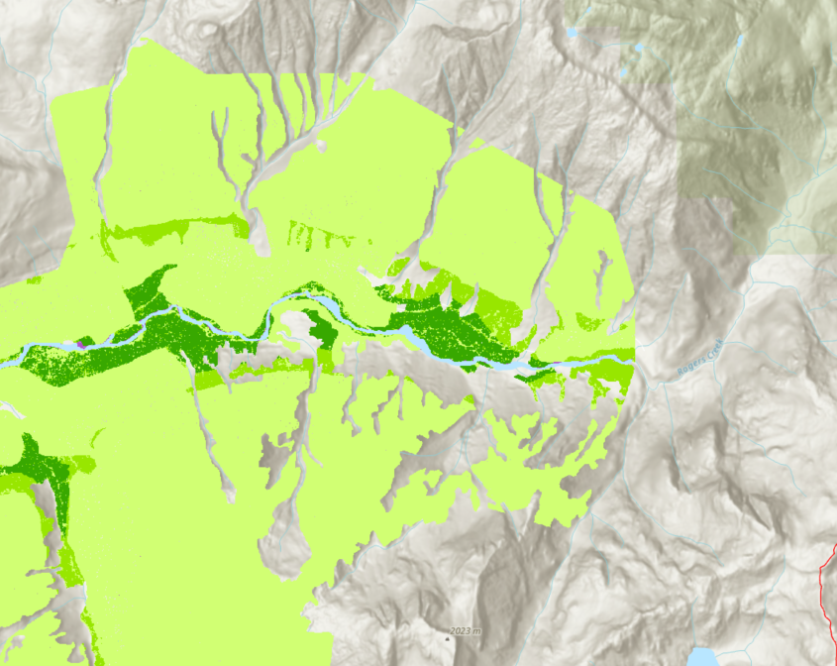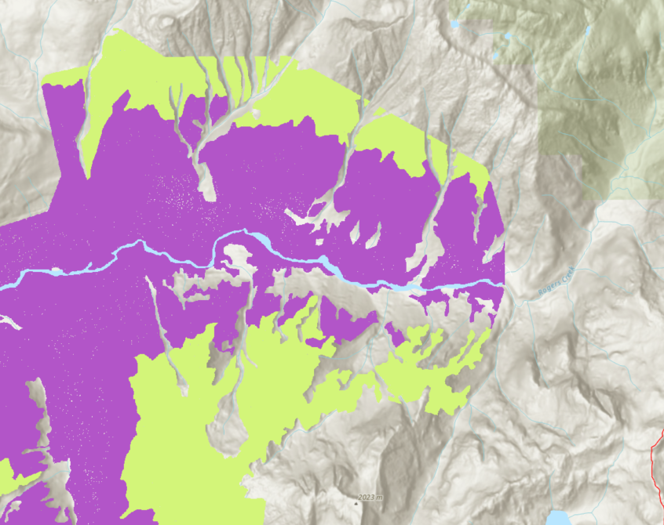  
Figure 47. Original Habitat Suitability vs. BEC Suitability.

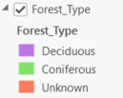Habitat suitability (Original) vs. Forest type:  
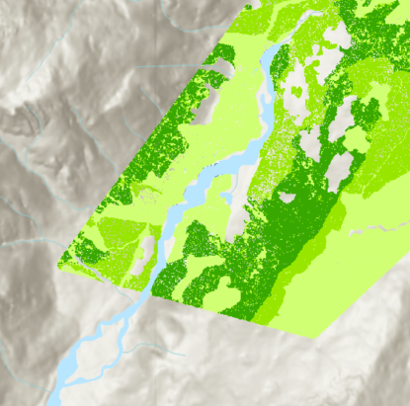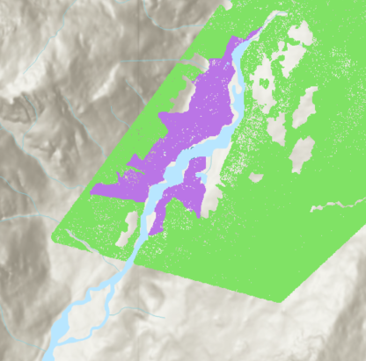  
Figure 48. Original Habitat Suitability vs. Forest Type.

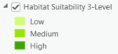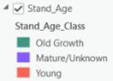Habitat suitability (Original) vs. Stand age:  
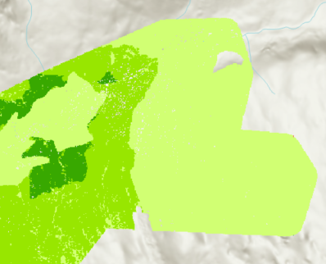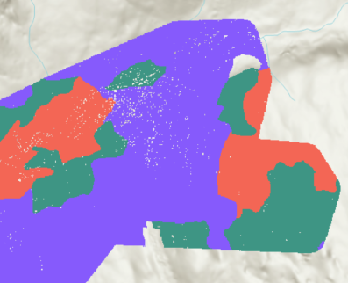  
Figure 49. Original Habitat Suitability vs. Stand Age.

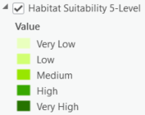3-Level Classification (Original) vs. 5-Level Classification (Original):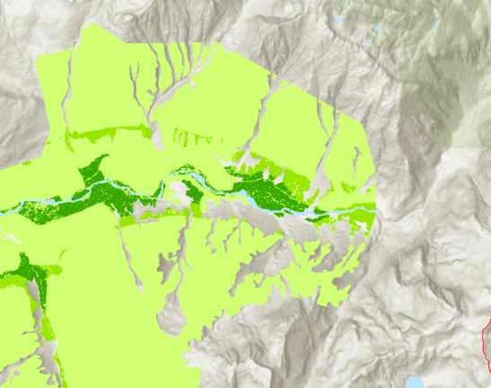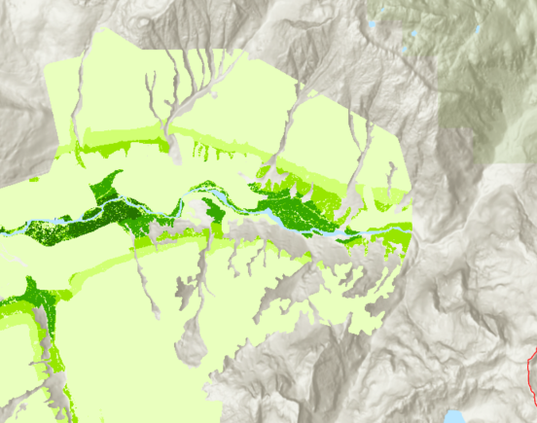  
Figure 50. 3-Level Classification vs. 5-Level Classification.

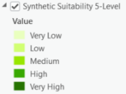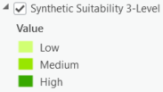3-Level Classification (Synthetic) vs. 5-Level Classification (Synthetic):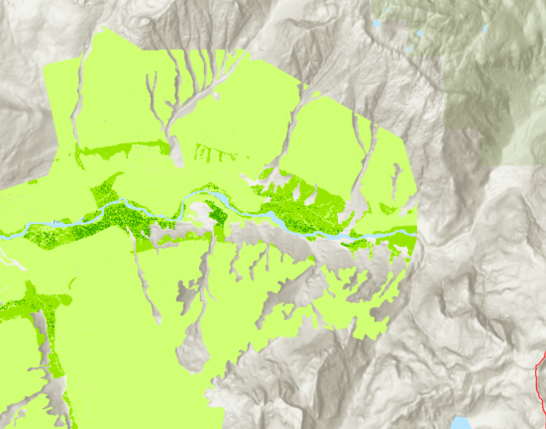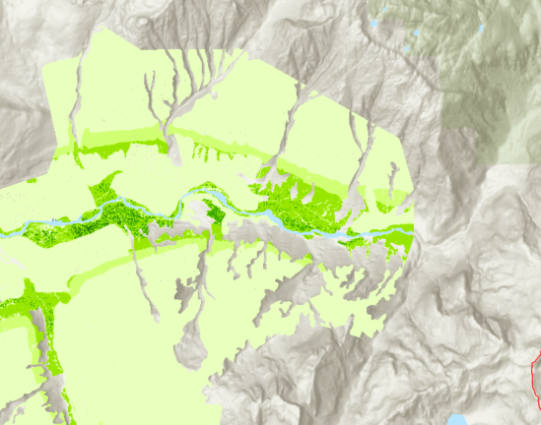  
Figure 51. 3-Level Synthetic Classification vs. 5-Level Synthetic Classification.

3-Level Classification (Original) vs. 3-Level Classification (Synthetic):  
Figure 52. 3-Level Classification vs, 3-Level Synthetic Classification.

5-Level Classification (Original) vs. 5-Level Classification (Synthetic):  
Figure 53. 5-Level Classification vs, 5-Level Synthetic Classification.

**Final Model:**

Due to the client's approval of the first two models, I developed a third MaxEnt model, "tsetspa7_ model_v2", using additional LiDAR data, with 23 goshawk occurrence points. This model does not include synthetic occurrence points, focusing solely on the expanded set of real occurrence data. The process was documented in an RStudio markdown notebook, "tsetspa7_model_v2". A regularization multiplier of 4 was applied to balance complexity and generalizability.

**70/30 Split Test Results**

The model was evaluated using a 70/30 train-test split with 7 test presence points:

* **Average Prediction on Test Presence Points**: 0.5498, indicating strong sensitivity to true positives.
* **Average Prediction on Test Background Points**: 0.2988, suggesting moderate specificity in distinguishing presence from background points.
* **Presence Points**: 23
* **Background Points**: 3195

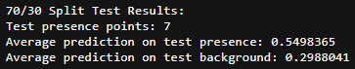  
Figure 54. Model 3 70/30 Test Results.

**Model Evaluation Metrics**

* **AUC (Area Under the Curve)**: 0.8268, reflecting good discriminatory ability, though lower than Models 1 and 2, likely due to the increased complexity of the LiDAR data and fewer occurrence points compared to Model 2.
* **Mean Predicted Suitability**: 0.288, indicating moderate habitat suitability across the study area.
* **Minimum Predicted Suitability**: 0.005
* **Maximum Predicted Suitability**: 0.9076, showing the model can identify highly suitable habitats.
* **Mean Suitability for Presence Points**: 0.5323, demonstrating reasonable accuracy for known goshawk locations.

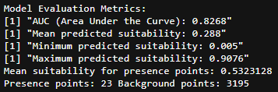  
Figure 55. Model 3 LOOCV Results.

**5-Fold Cross-Validation Results**

The model underwent 5-fold cross-validation, leveraging the 23 occurrence points for stable training and testing:

* **Average AUC**: 0.8275, consistent with the 70/30 split, confirming reliable discriminatory performance.
* **Average Mean Suitability (Presence)**: 0.5344, indicating good predictions for goshawk locations.
* **Average Mean Suitability (Background)**: 0.2891, aligning with the 70/30 split results and showing moderate background differentiation.

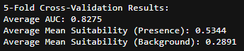  
Figure 56. Model 3 K-Fold CV Results.

**Area Distribution**

The area distributions highlight the model's habitat suitability predictions:

**3-Level Distribution**

* **Low**: 55.37% (34,019.28 ha), indicating a larger proportion of less suitable habitat compared to Models 1 and 2.
* **Medium**: 28.95% (17,786.3 ha), similar to Model 1 but lower than Model 2.
* **High**: 15.68% (9,633.73 ha), a smaller high-suitability area than both Model 1 (38.58%) and Model 2 (18.44%).

**5-Level Distribution**

* **Very Low**: 45.35% (27,860.26 ha), a significant portion of the study area.
* **Low**: 10.02% (6,159.02 ha), comparable to Model 1.
* **Medium**: 28.95% (17,786.3 ha), consistent with the 3-level distribution.
* **High**: 3.11% (1,908.78 ha), notably lower than both Models 1 and 2.
* **Very High**: 12.57% (7,724.95 ha), moderate compared to Model 1 (20.46%) and Model 2 (10.92%).

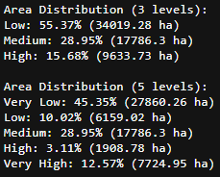  
Figure 57. Model 3 Area Distribution.

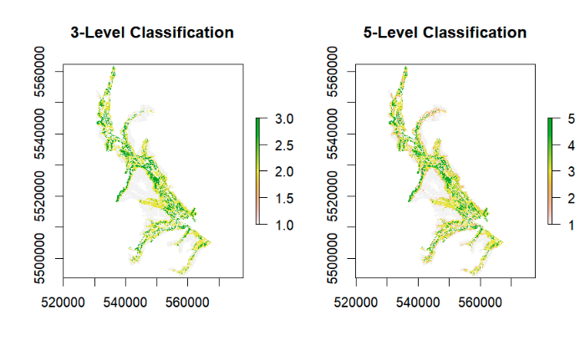  
Figure 58. Model 3 Classification.

**Discussion**

Model 3, incorporating LiDAR data and 23 occurrence points, provides a refined perspective on goshawk habitat suitability. Its AUC (0.8268 in 70/30 split, 0.8275 in 5-fold CV) is lower than Model 2 (0.9567 LOOCV, 0.9500 k-fold) and Model 1 (0.9182 LOOCV), likely due to the integration of complex LiDAR-derived environmental variables and a smaller dataset than Model 2. However, the model's mean suitability for presence points (0.5323) and high maximum suitability (0.9076) indicate it effectively identifies suitable habitats. The larger proportion of Low/Very Low areas (55.37% in 3-level, 45.35% Very Low in 5-level) suggests a more conservative suitability prediction compared to Models 1 and 2, potentially reflecting the detailed environmental insights from LiDAR data. When presenting, highlight Model 3's ability to leverage LiDAR for precise habitat mapping, while noting its lower AUC compared to Model 2's robust performance and Model 1's precision for the original 12 points.